### **Property Management Application using Salesforce**

# INTRODUCTION

* 1. Overview
  2. Property management is the supervision of residential, commercial, and industrial properties, including apartments, detached houses, Property management is the supervision of residential, commercial, and industrial properties, including apartments, detached house.
  3. Purpose

To manage front office capabilities,such as booking reservation,guest check-in/check out,room assingnment, managing room rates,and billing

1. **Problem Definition & Design Thinking**
   1. **Empathy Map**

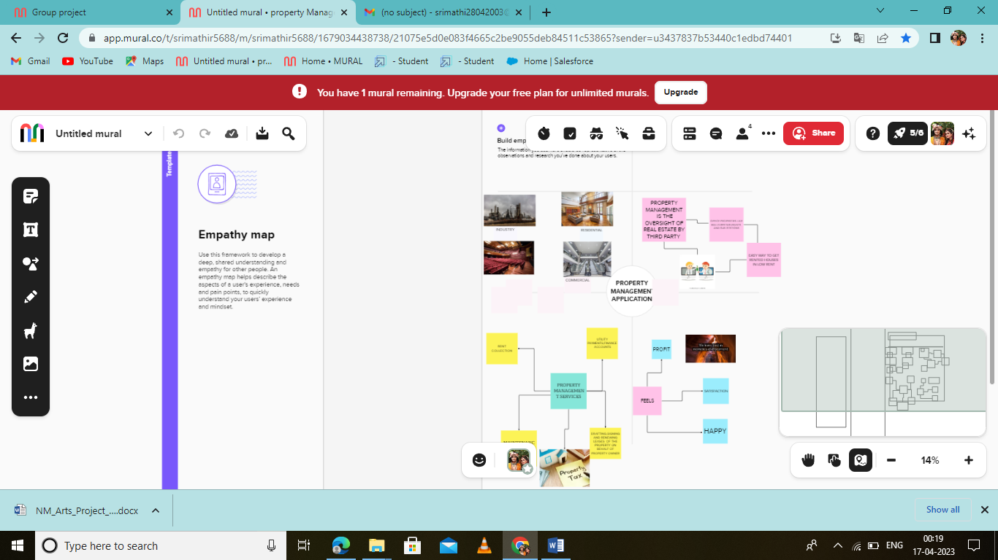

* 1. **Ideation & Brainstorming Map**

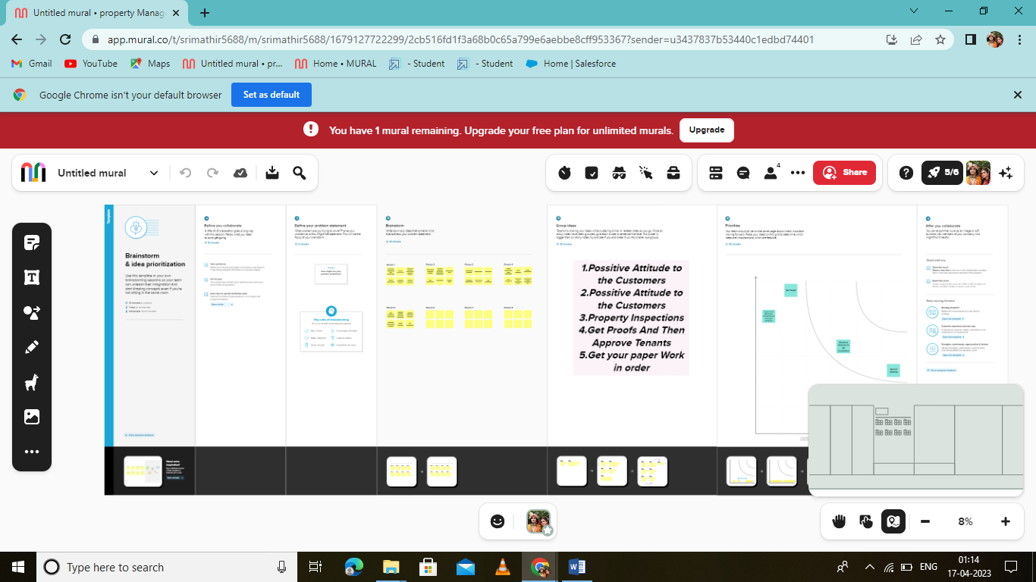

# RESULT

* 1. Data Model:

|  |  |
| --- | --- |
| Object Name | Fields in the object |
| Obj 1  Buy | |  |  | | --- | --- | | fields | Data type | | Discount | Percentage | | State | Picklist | |
| Obj2  Rent | |  |  | | --- | --- | | Fields | Data type | | BHK Type | Pick list | | Rent | Autonumber | |

# Activity & Screenshot

# MILESTONE 5

# ACTIVITY 2

# 

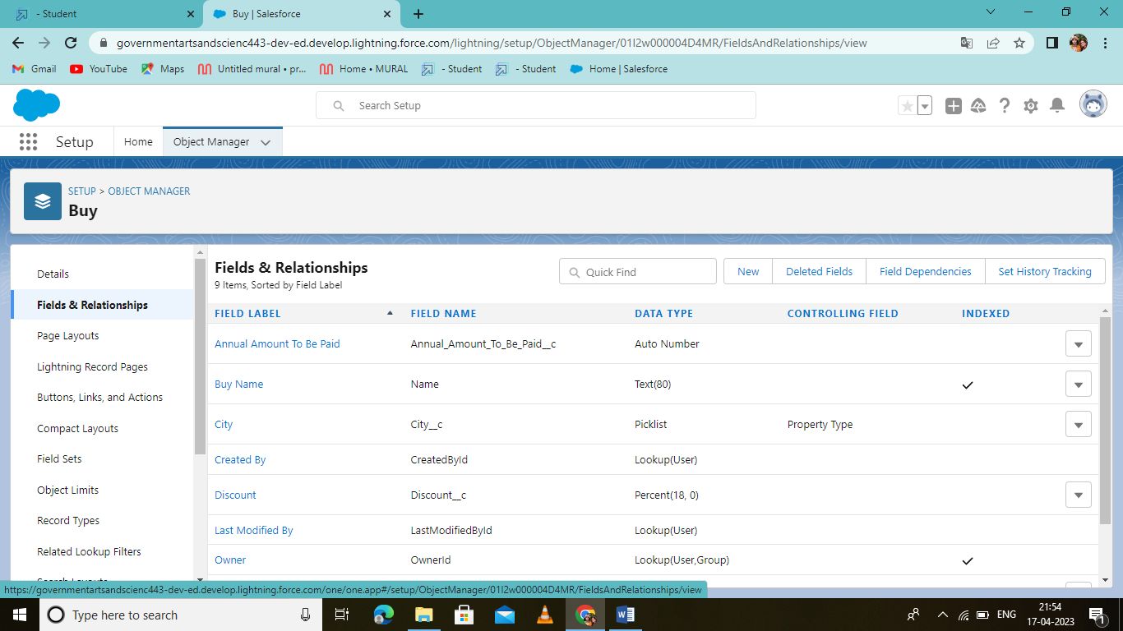

**MILESTONE 6**

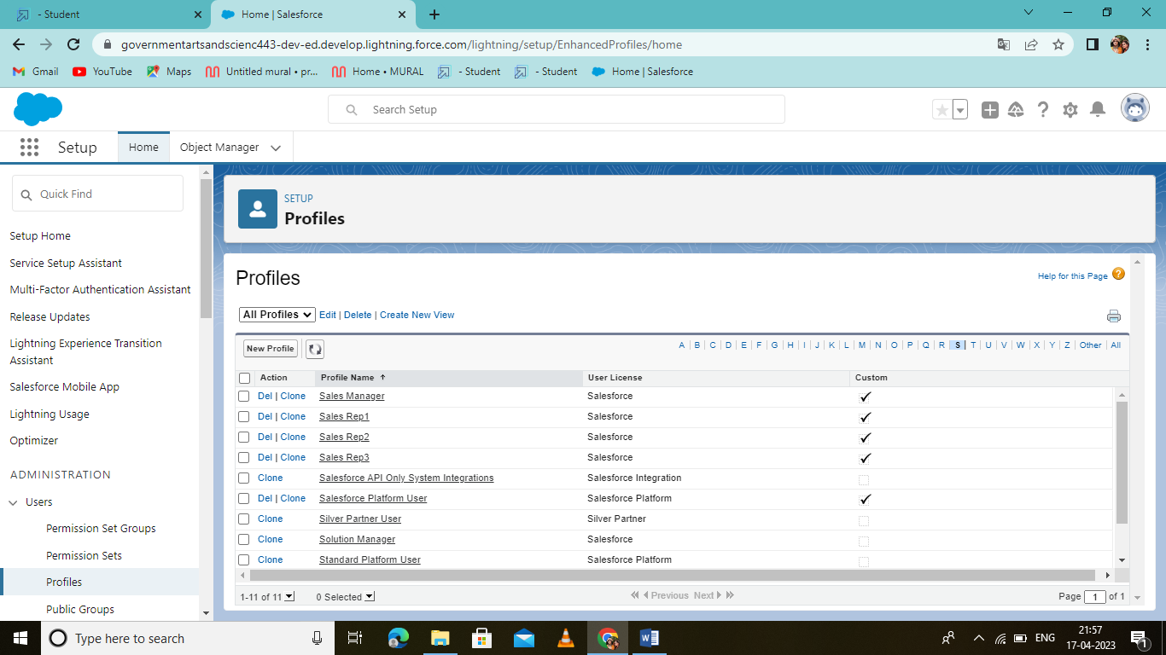

# ACTIVITY 3

# 

# 

# MILESTONE 4

# 

# 4 Trailhead Profile Public URL

**Team Lead –SRIMATHI.R**

**https://trailblazer.me/id/sraja677**

**Team Member 1-SRIVIDHYA.M**

<https://trailblazer.me/id/svidhyam>

**Team Member 2-SINDHU.K**

<https://trailblazer.me/id/rrona19>

**Team Member 3-VINITHA.G**

<https://trailblazer.me/id/vvini36>

**Team Member 4- KOWSALYA.C**

**https://trailblazer.me/id/strailhead**

1. **ADVANTAGES**

* Long-term tenants. ...
* More efficient rent collection. ...
* Lower repair and maintenance costs. ...
* Increase and maintain the value of your rental property. ...
* Personal benefits.

15-Nov-2018

# APPLICATIONS

property management system (PMS) is a software application for the operations of hospitality accommodations and commercial residential rental properties. PMS is also used in manufacturing industries, local govenment and manufacturing

# CONCLUSION

# Property Management System (PMS) software is very crucial for all the Hotels. Especially Opera PMS constitutes the most appropriate PMS

# FUTURE SCOPE

[**property managers are using new creative ways**](https://www.ncpropertygroup.com/blog/6-habits-of-successful-property-managers) and software to streamline it. When there is better communication between managers and clients, it opens up a whole world of opportunities for new services and benefits Instant messaging has taken over, leaving emails only

software is projected to grow at an unprecedented rate in the future of property management.